“The Caldwell Collection of Viols

a Life Together in the Pursuit of Beauty”

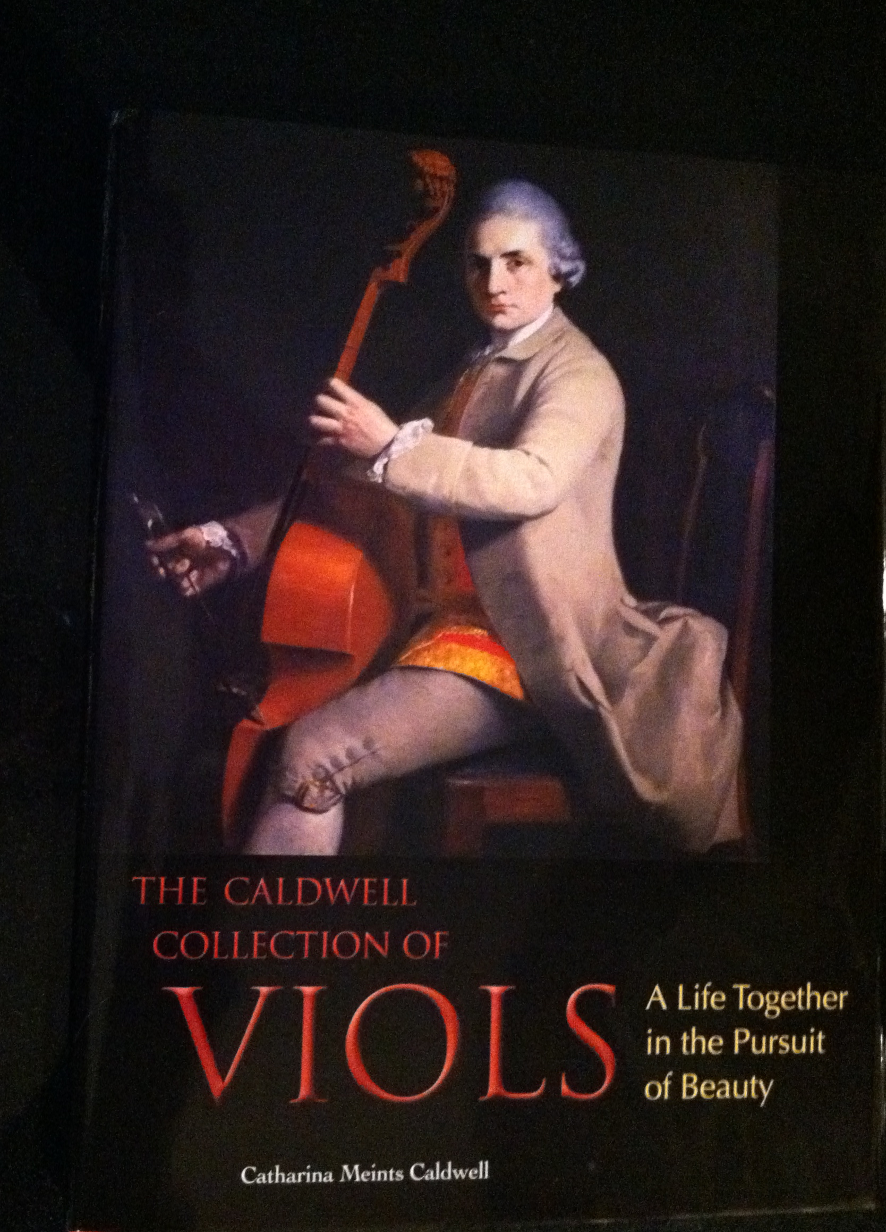

Catharina Meints Caldwell created this book and CD project in order to archive the important collection of viols and cellos that she and her husband collected, restored and played over a 35-year period. It is a catalogue of the instruments including photographs, paragraphs about the history and construction of the instruments, memoirs about the acquisition and restorations, and finally, two CDs on which Meints plays music from the same place and time each instrument was made. 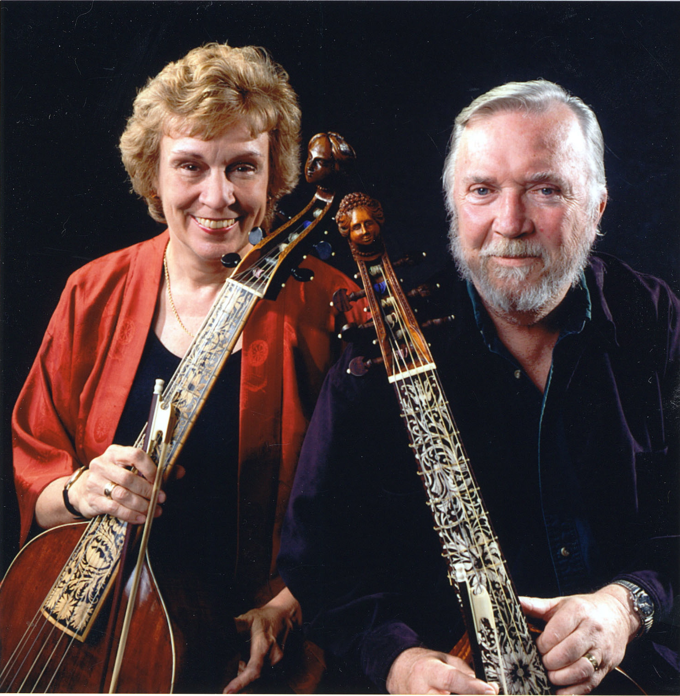

Catharina Meints and James Caldwell about 2002

From the “Strad” magazine:

“This book is an essential read for anyone interested in the viol.”

The book (with two CDs) is available from Amazon or directly from the author. Contact [virtualgem@aol.com](mailto:virtualgem@aol.com). The list price is 54$.

From Amazon:

“This sumptuous book presents the stringed musical instruments in the Caldwell Collection of Viols, including fine, rare, and important examples by Amati, Bertrand, Norman, Rose, Tielke, and others. Lavishly illustrated listings provide: \* 217 photographs, including full-page portraits of each instrument by Roger Mastroianni \*over 70 minutes of music, in 40 audio tracks \*details of provenance, dimensions, and restoration history \*technical descriptions of each instrument by the contemporary viol builder John Pringle \*essays on the makers by the musicologist Thomas G. MacCracken. The book is a moving and humorous memoir as well as a catalogue, telling the story of how the collection was shaped by the forty-year musical life together of its principals, and by their conviction that instruments, no matter how beautiful, are meant to be played and heard, not just looked at.”

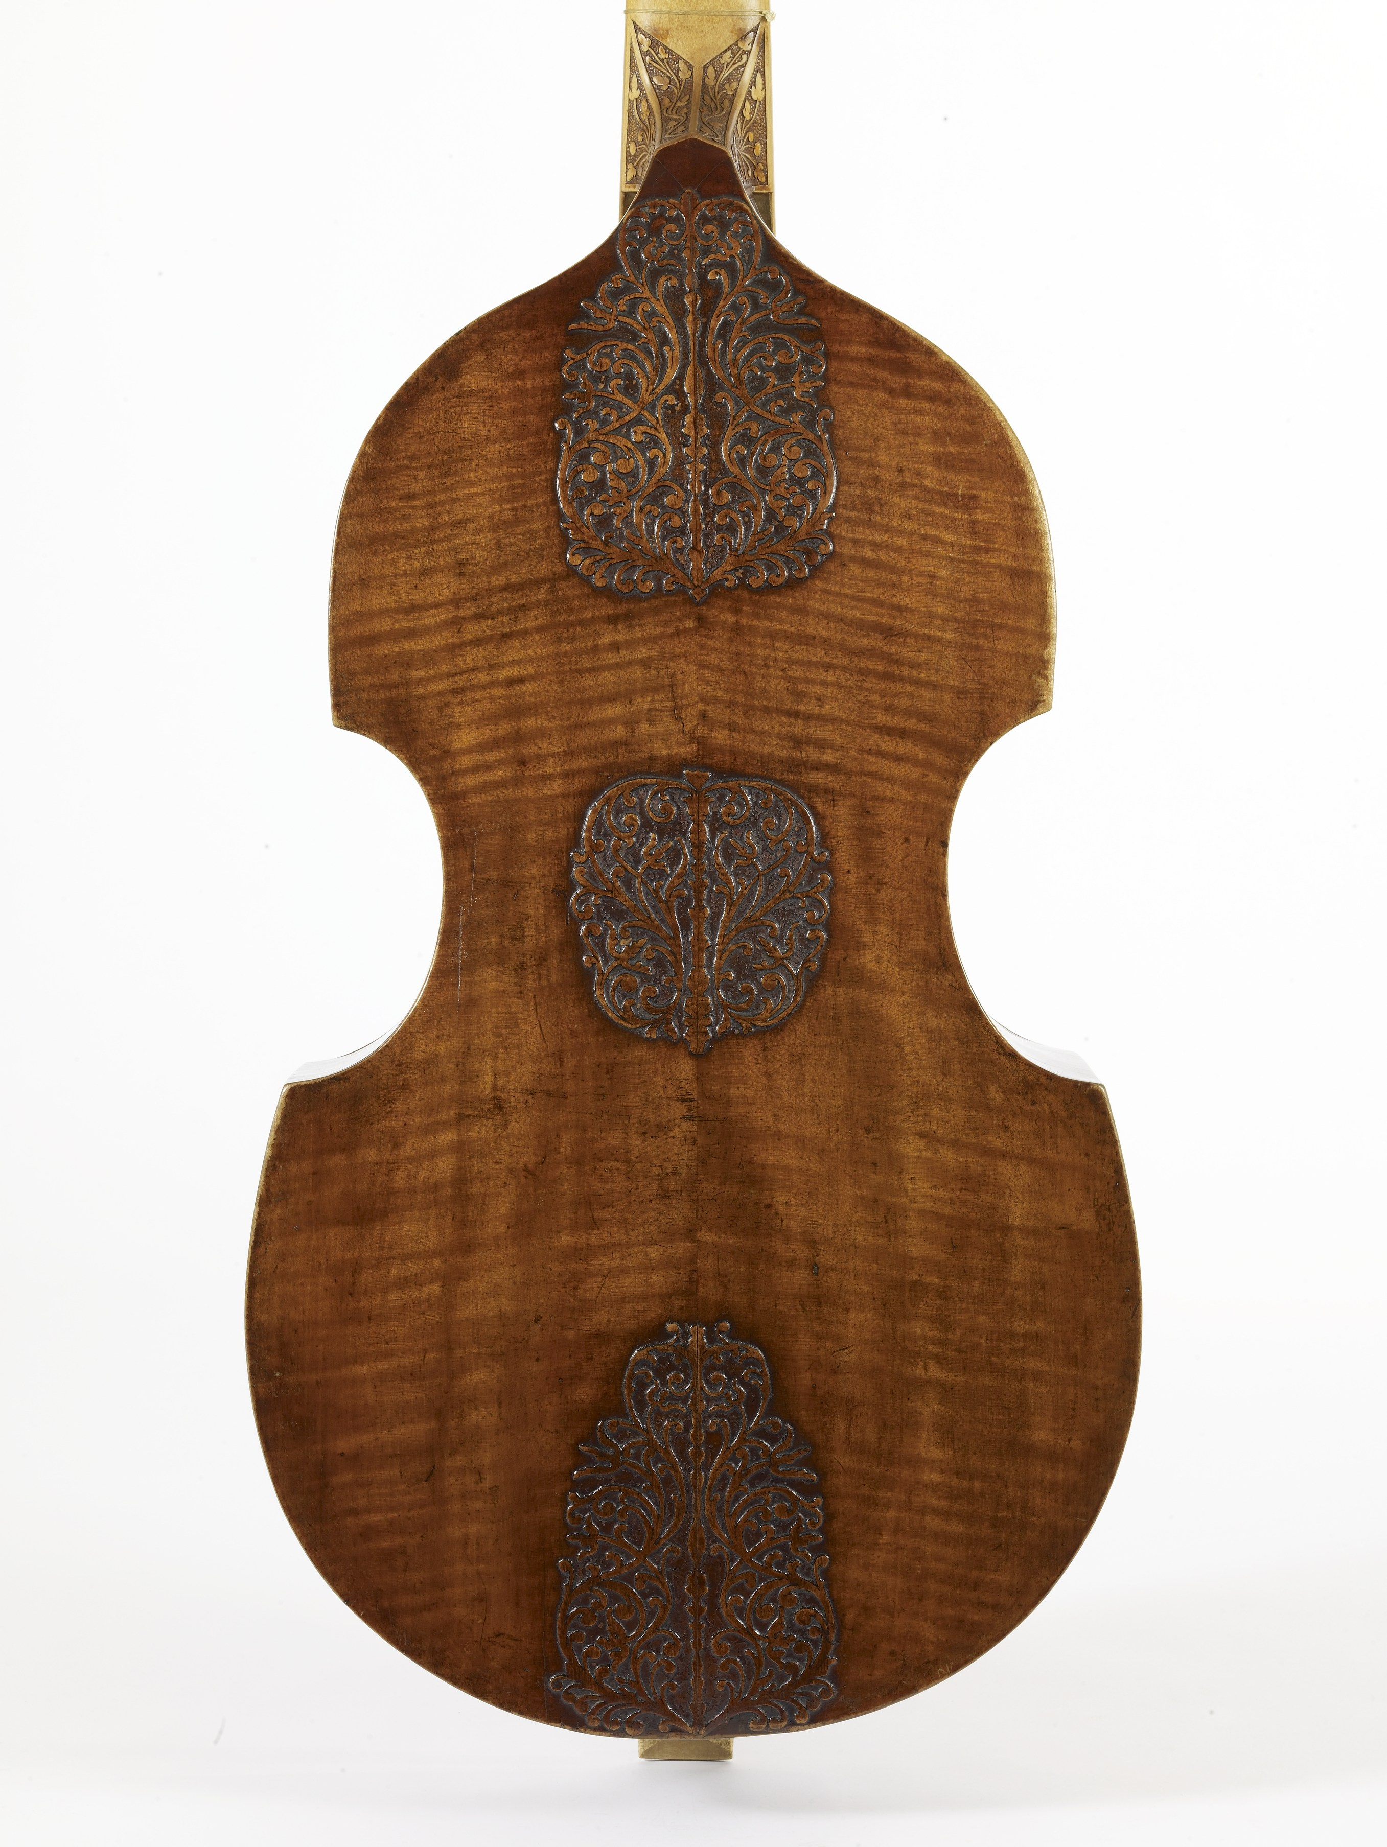

Joachim Tielke c.1680 Hamburg

[The Caldwell Collection of Viols: A Life Together in the ... -...](https://r.search.yahoo.com/_ylt=A0LEV0VLuWxapb4Abg5XNyoA;_ylu=X3oDMTEyYzFyYWQ2BGNvbG8DYmYxBHBvcwMzBHZ0aWQDVUkyQzNfMQRzZWMDc3I-/RV=2/RE=1517103564/RO=10/RU=https%3a%2f%2fvimeo.com%2f36099600/RK=2/RS=pi35V0d0HpHcGVfRmvtjuumC7nY-" \t "_blank)

vimeo.com/36099600

Can you reproduce the video that is part of this entry that I found when I googled The Caldwell Collection of viols”?

From “Early Music America” Can you reproduce this entire article on the website?

### [a life together in the pursuit of beauty - Early Music America](https://r.search.yahoo.com/_ylt=A0LEV0VLuWxapb4Acw5XNyoA;_ylu=X3oDMTEyaDI5cWNhBGNvbG8DYmYxBHBvcwM2BHZ0aWQDVUkyQzNfMQRzZWMDc3I-/RV=2/RE=1517103564/RO=10/RU=https%3a%2f%2fwww.earlymusicamerica.org%2ffiles%2fA-Life-Together-in-the-Pursuit-of-Beauty.pdf/RK=2/RS=qXhchLQ8oOwXWxENLNNAquZbHQs-" \t "_blank)

www.earlymusicamerica.org/files/A-Life-Together-in-the-Pursuit-of-Beauty.pdf

Jul 27, 2012 ... THUS Catharina Meints Caldwell begins the preface to her new catalogue of the 22-instrument Caldwell. Collection of Viols. More than just a checklist, with measurements and pictures, the catalogue pays tribute to. Jim and Cathy's 39- year personal and professional partnership—“a life together in the ...

‘]]]] 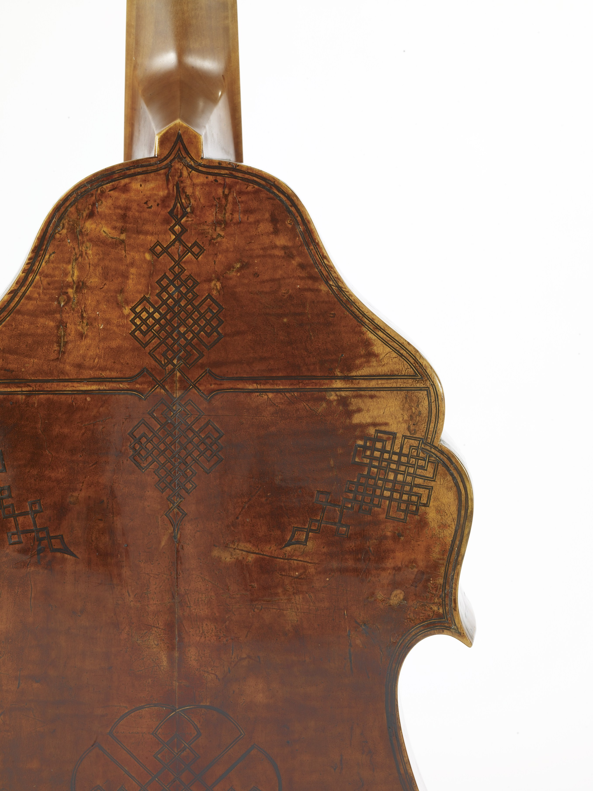Attributed to John Rose 1600 London